



CONTACT: CAL FIRE PIO (916) 651-3473 Calfire.dutypio@fire.ca.gov

RELEASE DATE: January 9, 2025

January 2025 Fire Summary

Sacramento – More than 7,500 personnel, including firefighters, law enforcement and other emergency support personnel, are on the ground working with local and federal partners to respond to ongoing historic wildfires in Southern California. Yesterday, firefighters also responded to 37 new wildfires across the state. In the first nine days of the year, there have been 29,053 acres burned, from 92 fires.

CAL FIRE has activated two Incident Management Teams to manage the Palisades and Eaton Fires. A third team has been pre-positioned to Souther California in response to the increased fire threat.

Validated damage inspection is underway, but initial assessments estimate that thousands of structures have been destroyed in the Palisades and Eaton fires.

A large contingent of water tenders are being used to provide water to ensure firefighters have adequate water supply for firefighting. Governor Gavin Newsom announced Wednesday that California is mobilizing up to 140 2,500-gallon water tenders to assist in fighting the Eaton and Palisades fires.


  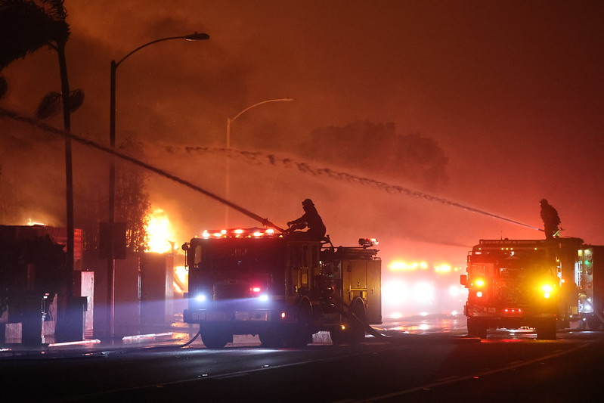
California continues to receive support and resources from nearby states including Oregon, Washington, Utah and Nevada.

A Red Flag Warning is in effect through 6 p.m. Friday, January 10, 2024, for moderate to strong north to northeast winds and low relative humidity for the central and southeastern Ventura County valleys, the valleys of Los Angeles County including Calabasas and Agoura hills, the Ventura and Los Angeles County mountains including the Santa Monica range and the Santa Susana Mountains, the Interstate 5 corridor and the Malibu coast. The Red Flag Warning is also in effect for the inland valleys, foothills, and mountains in San Diego and Riverside counties.

With the Red Flag Warning in effect, CAL FIRE is urging all Californians to take extreme caution to prevent sparking a wildfire. With gusty winds, coupled with warm and dry conditions, fire danger will be elevated. The public is asked to take steps to prevent sparking a wildfire. To learn more, visit ReadyForWildfire.org.
ist in fighting the Eaton and Palisades fires.

**Unified Command Fires**
Palisade Fire, Los Angeles County (more info…)
Pacific Palisades and Topanga
*17,234 acres, 0% contained
*Over 1,000 structures
*Damage assessment is ongoing
*Evacuation orders and warnings in place for multiple communities
*350 engines, 49 crews, 88 dozers, 29 helicopters, 53 water tenders, 836 personnel
*Unified Command CAL FIRE, L.A. County Fire Department, L.A. City Fire Department, L.A. Police Department
*CAL FIRE Incident Management Team 2
Situation Summary: Extreme fire behavior, including short and long-range spotting, continues to challenge firefighting efforts for the Palisades Fire. Winds gusts up to 60 MPH are expected to continue through Thursday, potentially hindering fire suppression efforts.

Eaton Fire, Los Angeles County (more info…)
North Pasadena and Altadena
*10,600 acres, 0% contained
*Approximately 1,000 structures destroyed
*Damage assessment is ongoing
*Evacuation orders and warnings in place for multiple communities
*306 engines, 27 crews, 4 dozers, 11 helicopters, 73 water tenders, 702 personnel
*Unified Command CAL FIRE, USFS, L.A. County Fire Department, Pasadena Fire
*CAL FIRE Incident Management Team 3
Situation Summary: Firefighters are working aggressively to slow the spread and protect critical infrastructure under extreme conditions and significant growth has been stopped. Residents in evacuated areas are urged not to drink tap water. Use only bottled water. Failure to do so may result in illness.

Hurst Fire, Los Angeles County (more info…)
Stetson Ranch Park
*671 acres, 10% contained
*Damage assessment is ongoing
*Evacuation orders and warnings in place for multiple communities
*62 engines, 13 crews, 9 dozers, 5 water tenders, 300 personnel
*Unified Command CAL FIRE, USFS, L.A. County Fire Department, L.A. City Fire Department, L.A. County Sheriff
Situation Summary: Firefighters have successfully contained the fire north of the I-210 Foothill Freeway, establishing control lines extending to Santa Clara Divide Road. Crews managed several flare-ups within the fire's perimeter. Efforts for the early morning hours of 1/9 will focus on reinforcing control lines and strategically using dozer lines to limit the fire's spread.

**Federal Fires**
Lidia Fire, Los Angeles County (more info…)
Soledad Canyon
*348 acres, 40% contained
*There are no evacuation orders currently in place
*14 engines, 1 dozer, 2 water tenders
* USFS Angeles National Forest
Situation Summary: Forward progress has been stopped on this brush fire. Firefighters are working hard to gain additional containment.

**Local Fires**
Sunset, Los Angeles County (more info…)
Runyon Canyon
*43 acres, 0% contained
*Damage assessment is ongoing
*All evacuation orders lifted
*25 engines
* L.A. City Fire Department
Situation Summary: The majority of the Evacuation Zone for the Sunset Fire is lifted except for the area North of Franklin Ave from Camino Palmero St (East border) to North Sierra Bonita Ave. (West border).

Safety Messaging:
- The recent spike in wildfire activity is an important reminder for residents to take steps to prevent sparking a wildfire. Having an evacuation plan, a supply kit, and important paperwork will make it easier when it is time to GO. Remember one less spark, means One Less Wildfire. Learn more at ReadyForWildfire.org.

Stay informed of emerging fires by bookmarking Incidents | CAL FIRE

