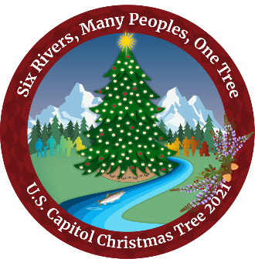
The City of Sonora, County of Tuolumne and the Stanislaus National Forest Invite you to the Community Reception for the US Capitol Christmas Tree on:
Wednesday, November 3, 2021
From 5 – 7 pm at the Mother Lode Fairgrounds
…As the tree winds its way from Six Rivers National Forest in Northern California to Washington DC!
Fun agenda!
- Line Washington and Stockton Streets between 4-5 pm to be the first to welcome the tree as it is escorted to the fairgrounds by the Sheriff’s Posse on horseback, followed by Sonora’s Newest Fire Engine with Santa, and Fire Engines from Tuolumne County Fire and the Stanislaus National Forest.
- Enjoy a Native American Blessing, live music by the Pinecone Performers, welcome address from the Six Rivers National Forest, Sonora Mayor, County Board of Supervisors Chairman, and the Stanislaus Forest Supervisor.
- Participate in activities at the Motherlode Fairgrounds such as: Signing the 80’ banner that accompanies the tree, take a “Walk Through the Forest” – a 120’ walkway with a guided forest experience. Kids to receive USFS goodie bags!
- Hot Cocoa and Hot Spiced Cider provided to participants along with other activities.
- Kids: Use this tree tracker website: https://www.capitoltreetracker.com
- Bundle up, wear winter clothing, and bring your flashlight!
- Social distancing protocols will be in place; hand sanitation stations will be available. Please wear a mask if unable to maintain social distance and stay home if feeling ill.
Co-Sponsors for this Event:
Visit Tuolumne County https://www.visittuolumne.com/capitol-christmas-tree
Sonora Chamber of Commerce http://www.sonorachamber.org/
Tuolumne Chamber of Commerce https://tcchamber.com/
Yosemite Hwy 120 Chamber of Commerce www.groveland.org
This is a free family friendly event

